**Now in its 4th year, Pride Ride Utah aims to build community, increase access, and break down barriers to LGBTQ+ inclusion in the ski and ride community.**

Pride Ride Utah is organized by a group of volunteers who are passionate about mental health and snow sports. We want to increase access, therefore this event is always free to attend; however, does not include a lift ticket. In order to increase accessibility, Brighton is providing a discount code for participants and Christy Sports on Wasatch Blvd is providing free rental equipment to participants. The Pride Ride celebration will take place from 8am-4pm at Brighton, and the after party is at Evo Hotel beginning at 7pm.

As usual, PRU will be fundraising for a local non-profit through donations, silent auction, and a raffle. All donations will be tax deductible. This year’s local non-profit is [Rock Camp](https://www.rockcampslc.org/), whose mission is “Empowering girls, transgender, non-binary, and gender-expansive youth from all backgrounds through music education, collaboration, and performance”.

**Requests for your support:**

* Show up and participate! We have limited tent/booth space available at Brighton, prioritized for donors
* Donations for raffle items (e.g., ski/ride gear, gift certificates, outdoor gear, etc.)
* Donations for swag bags (e.g., bags/totes, sunglasses, bottle openers, stickers, etc.)
* A sponsor to collaborate with the design and funding of a branded koozie, buff, beanie (or something similar) as a 2024 commemorative item, which would include the PRU logo, Brighton logo, and your business logo
* Sharing and promoting the event on social media and in stores
* Monetary donations to provide free or reduced-cost lift tickets and/or lessons to first-timers
* Charter bus transportation for participants to get to/from SLC to Brighton

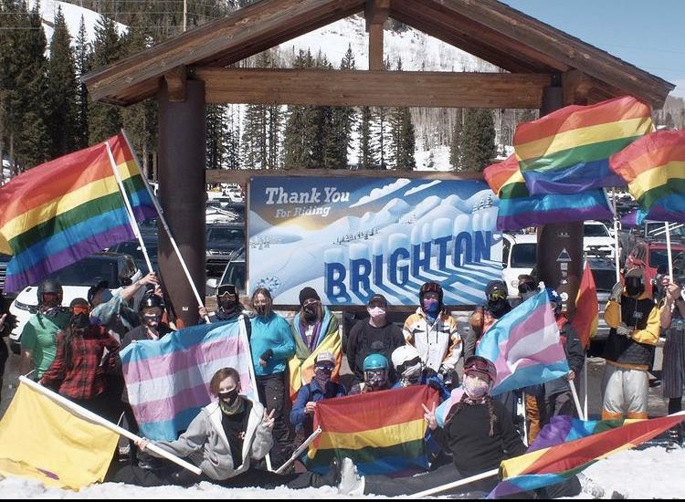 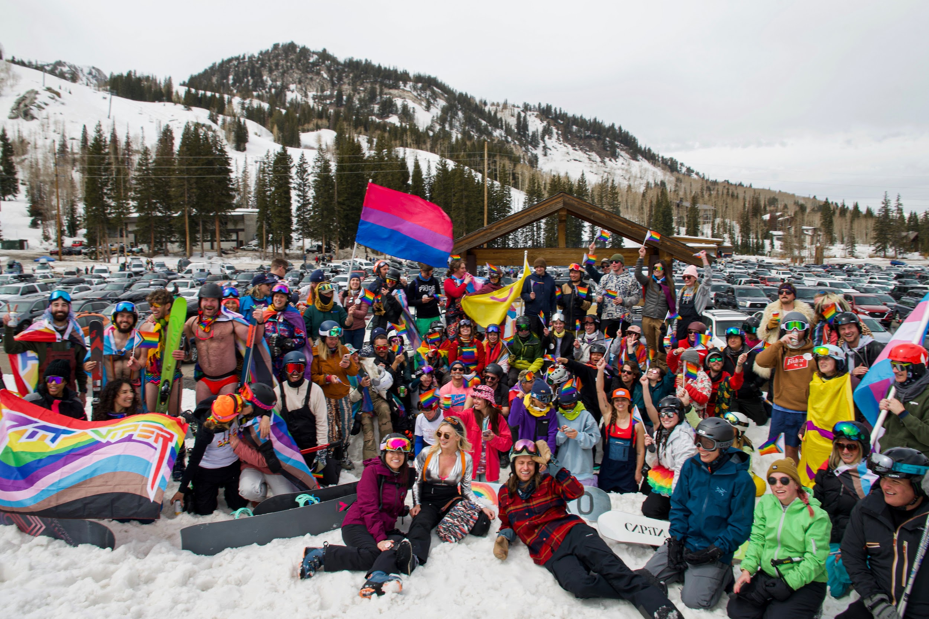 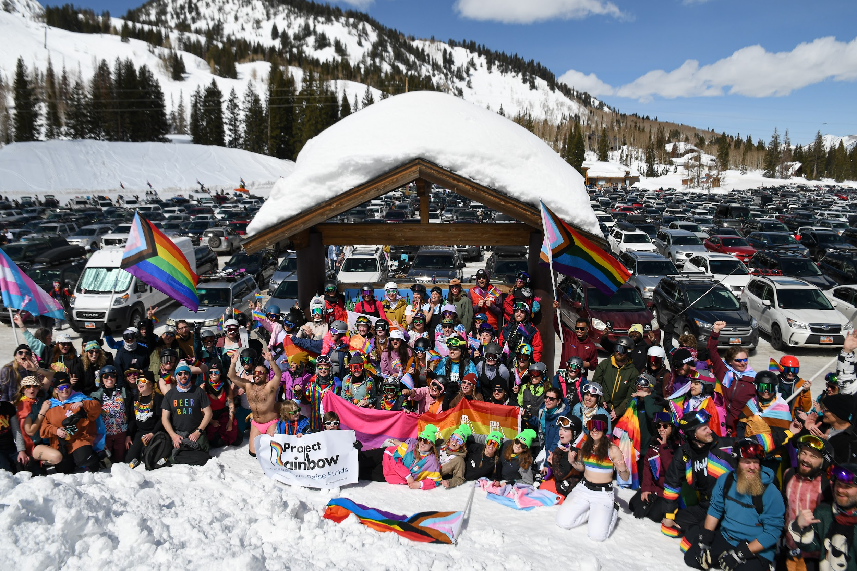

2021: 35+ participants 2022: 250+ participants 2023: 450+ participants